# AZURE MAJOR PROJECT

**TOPICS:-**

* Create a Resource group by Name (VerzeRG01).
* Create a Virtual network (verzvnet01).
* Create a virtual machine in the portal(VerzVM01).
* Create blob storage(VerzSTR01).
* Create a File Share (Verzfs01)and mount on the (VerzVM01).
* Create a network security group.
* Configure an inbound security port rule to allow RDP.
* Configure an outbound security port rule to deny Internet access.
* Create an Azure Policy to only allow certain locations (Southeast Asia), try to create a resource in any other location and check the policy evaluation. (You can use any other region).
* Apply a lock on the (VerzeRG01) and test if you are allowed to delete any resource.
* Setup CPU Threshold alert for the VM (VerzVM01).
* Create Action(Verzactgrp) Group for the above alert with your email id.
* Check if you are receiving the alert.
* Create a Recovery Services vault (Vezvault01) in the Resource Group (VerzeRG01).
* Setup Backup for the Virtual Machine (VerzVM01) and ensure backup is completed successfully.

**Output** - Create a Word Document and attach all the screenshots of the above activity along with one liner description.

* Resource group:

A Resource group is simply a logical construct that groups multiple resources together so they can be managed as a single entity based on lifecycle and security.

* VerzeRG01 Resource group is created.

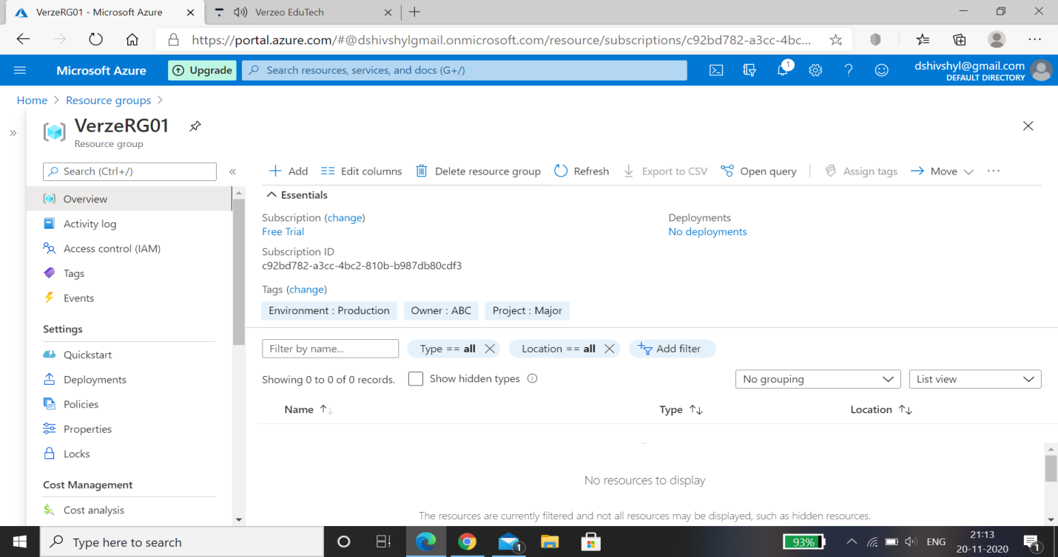

* Virtual Network:

A virtual network is a network where all devices, servers, virtual machines, and data centers that are connected are done so through software and wireless technology.

* Verzvnet01 Virtual Network is created.

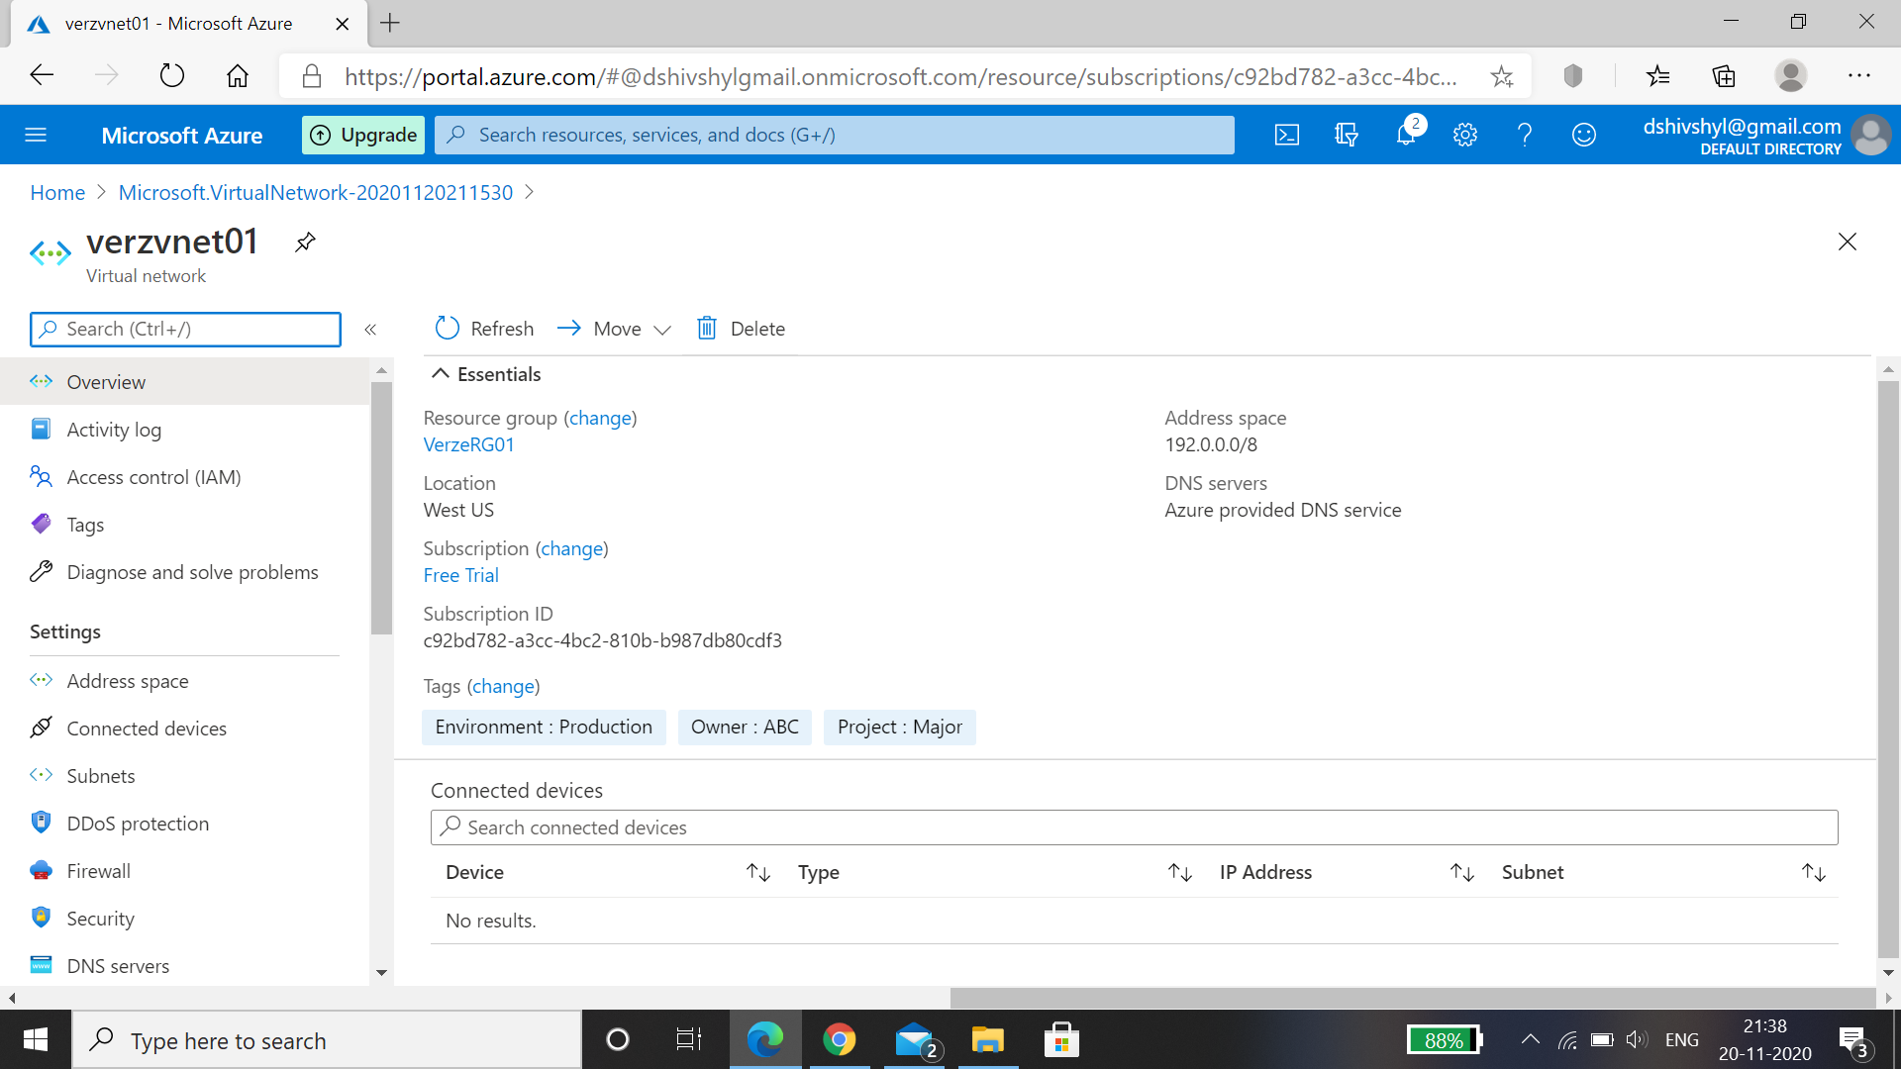

* Virtual Machine:

A virtual machine is an emulated computer system created using software. It uses physical system resources, such as the CPU, RAM, and disk storage, but is isolated from other software on the computer.

* VerzVM01 Virtual Machine is creataed.

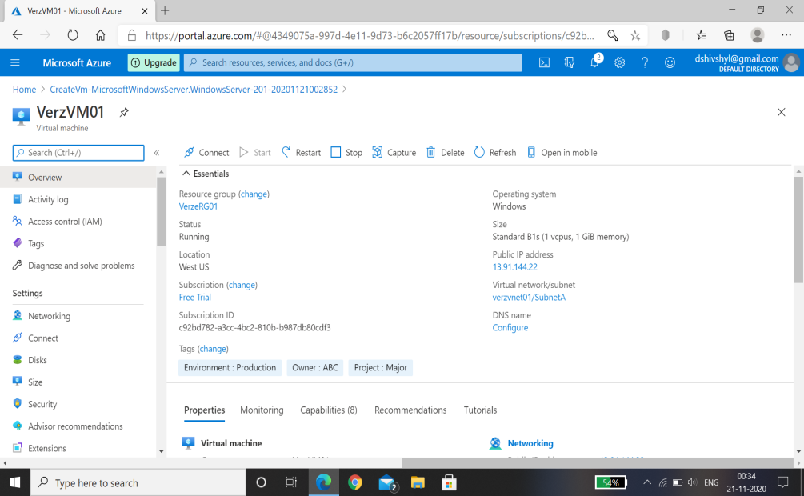

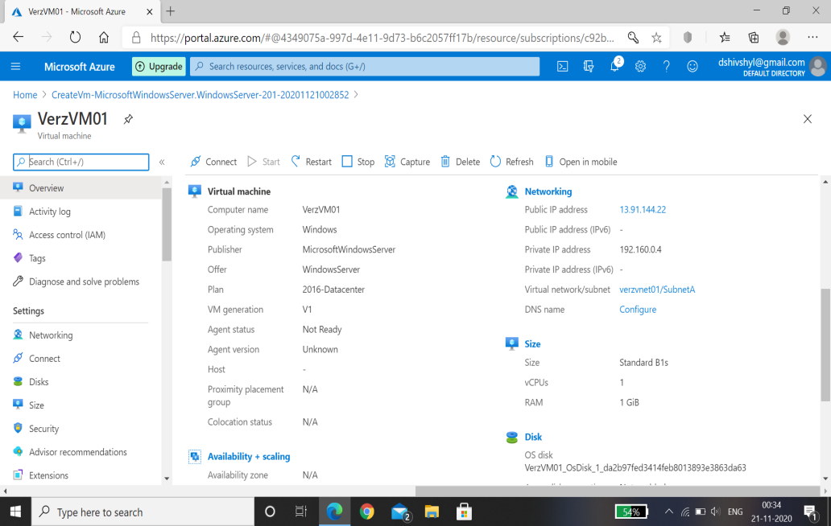

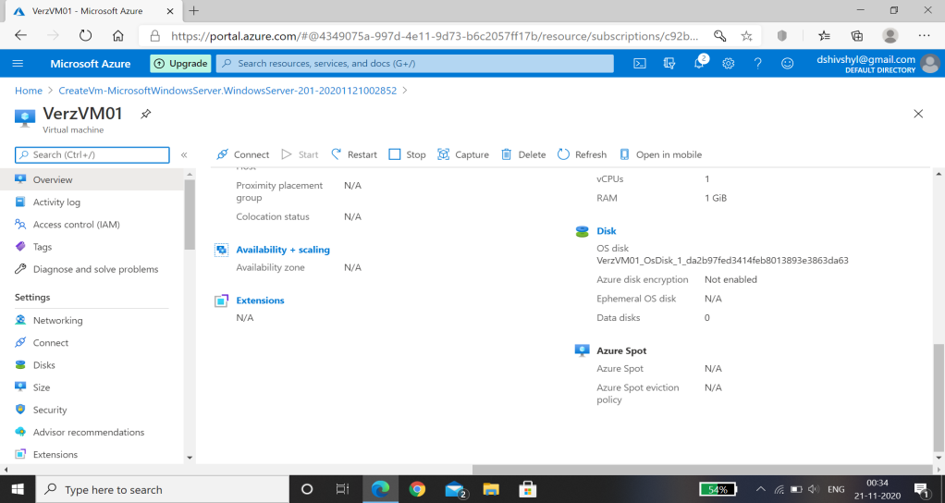

* Blob Storage:

Blob storage is a feature in Microsoft Azure that lets developers store unstructured data in Microsoft's cloud platform. This data can be accessed from anywhere in the world and can include audio, video and text. Blobs are grouped into "containers" that are tied to user accounts.

* Blob storage (VerzSTR01) is created.

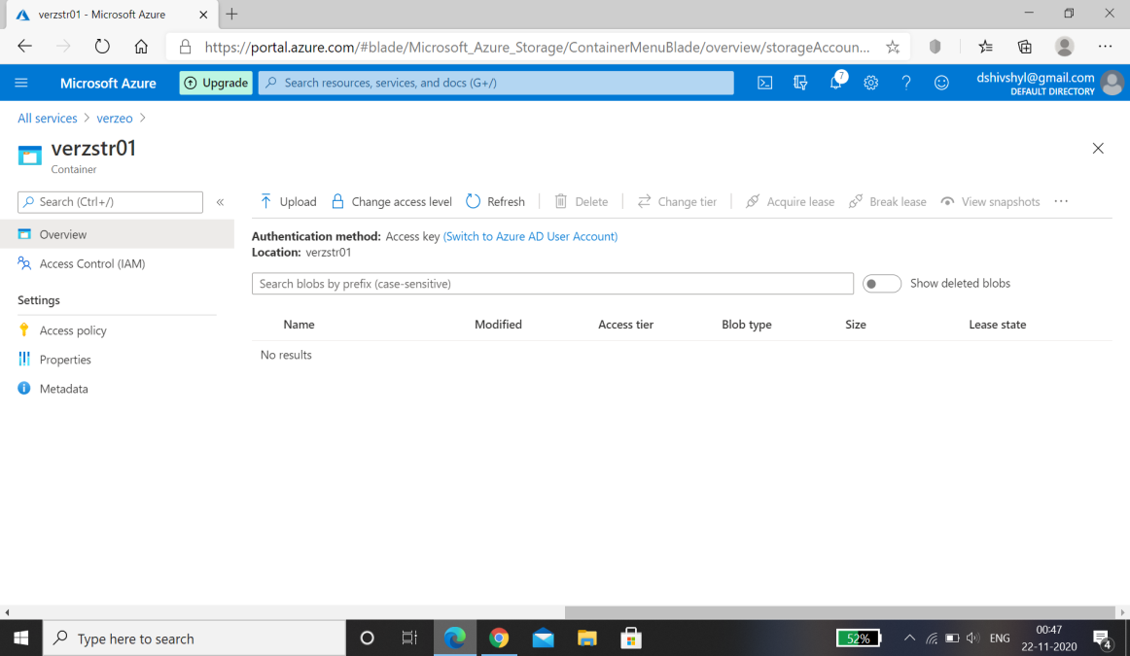

* File Share:

Blob storage is a feature in Microsoft Azure that lets developers store unstructured data in Microsoft's cloud platform. This data can be accessed from anywhere in the world and can include audio, video and text. Blobs are grouped into "containers" that are tied to user accounts.

* File Share(Verzfs01) is created.

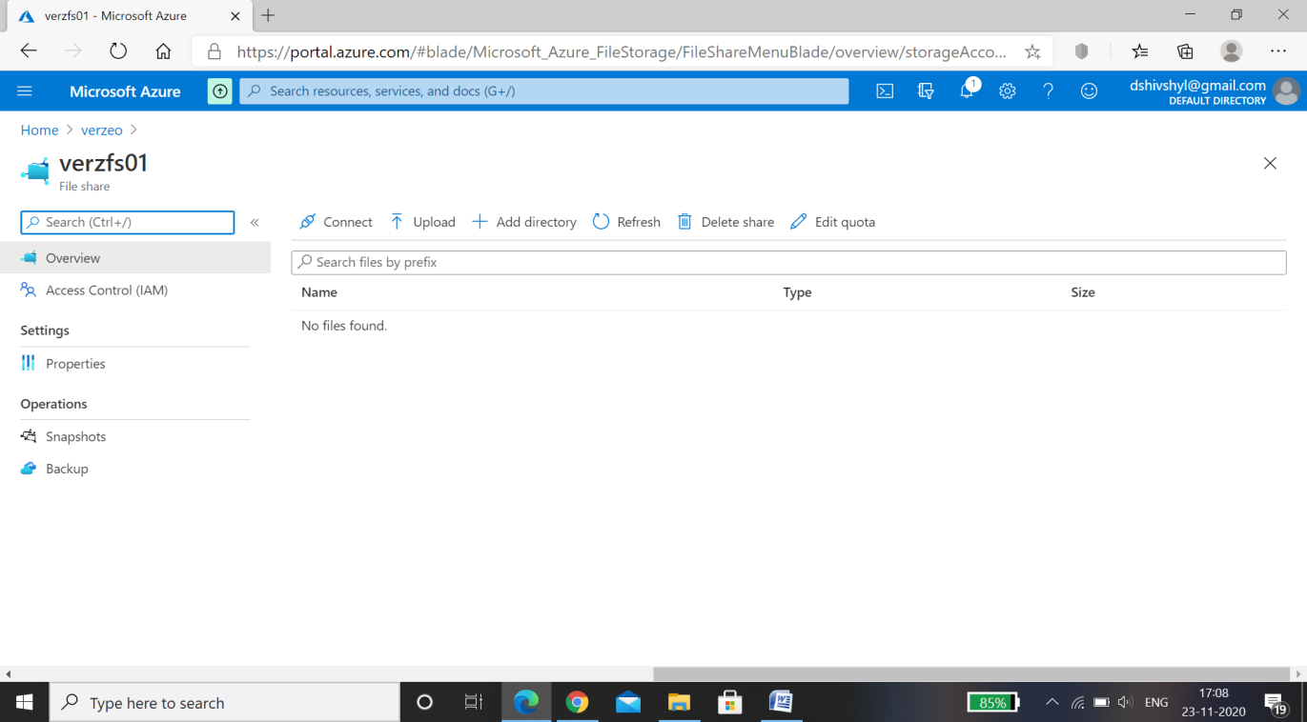

* File Share Verzfs01 is mounted on the Virtual Machine VerzVM01.

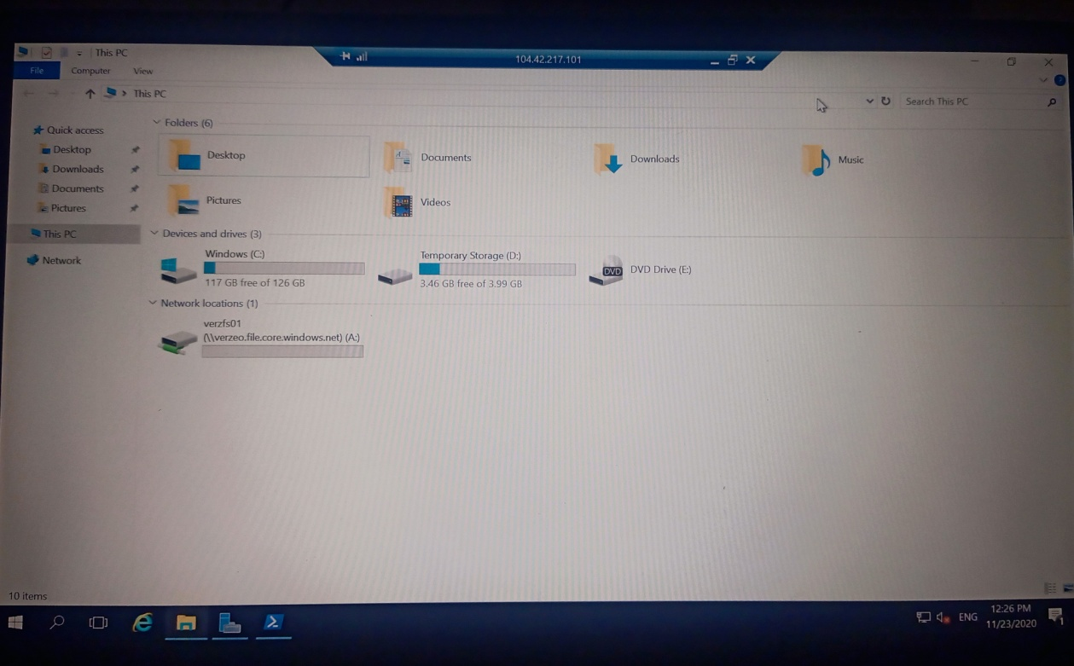

* Network security group.

A Network Security Group consists of a set of access control rules that describe traffic filters. These can be associated with a virtual machine or a subnet in the same region. The rules defined in the Network Security Group act as filters. On the ingress path they are applied before traffic enters the VM

* Network security group.

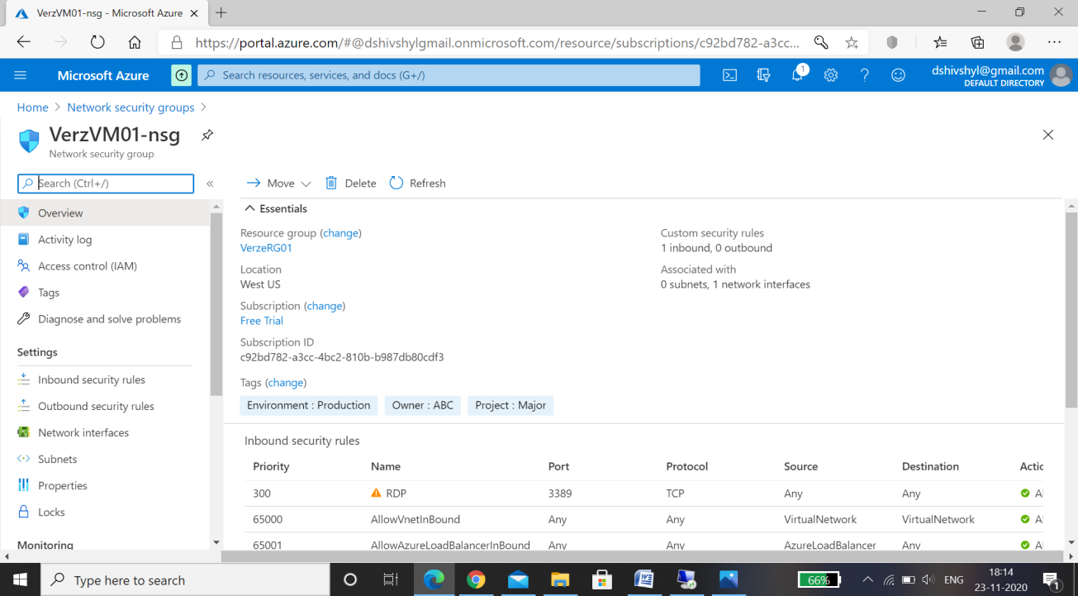

* Configuring an inbound security port rule to allow RDP.

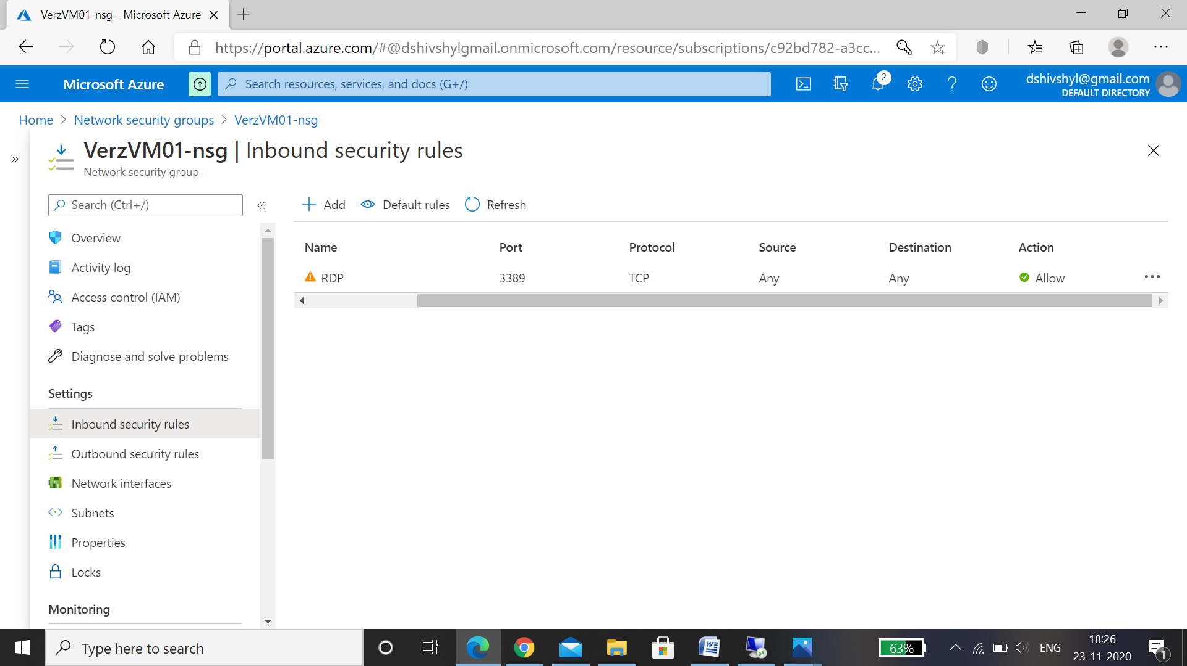

* Configuring an outbound security port rule to deny Internet access.

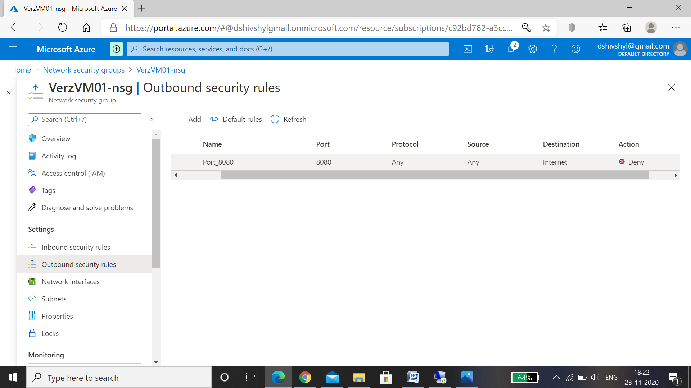

* Azure policy

Azure Policy establishes conventions for resources. Policy definitions describe resource compliance conditions and the effect to take if a condition is met. A condition compares a resource property field or a value to a required value. Policy assignments are inherited by child resources

* Azure Policy to only allow Southeast Asia locations . Resource in any other location is not allowed .

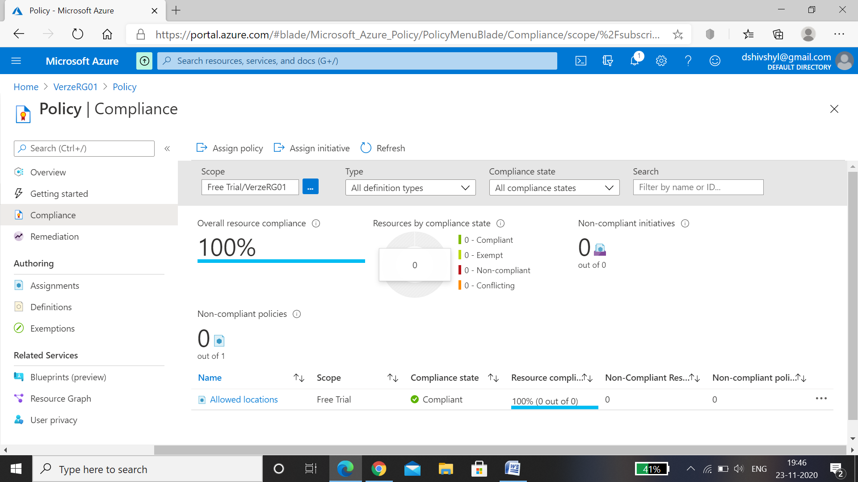

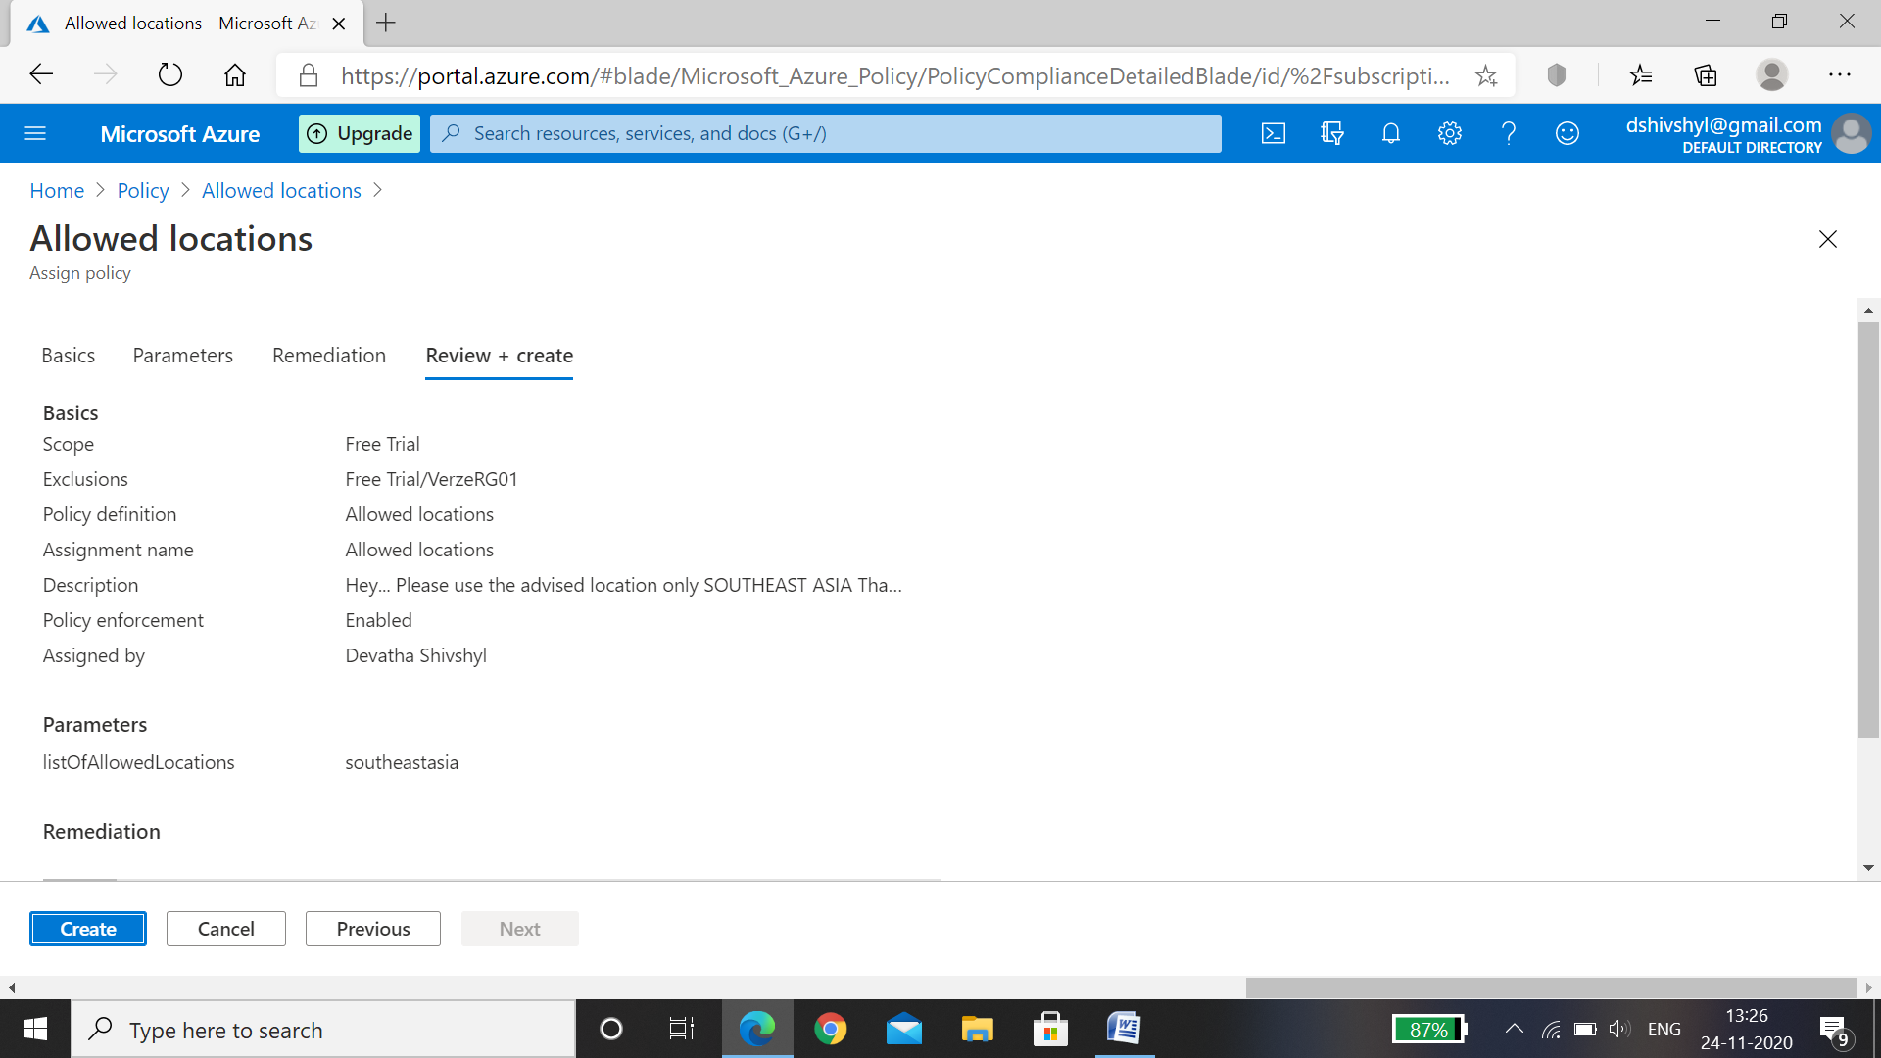

* The Resource Group VerzeRG01 is locked, and we are not allowed to delete any resource.

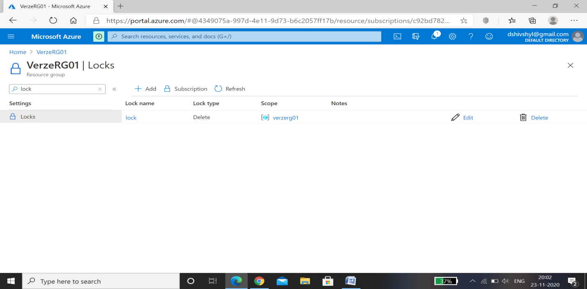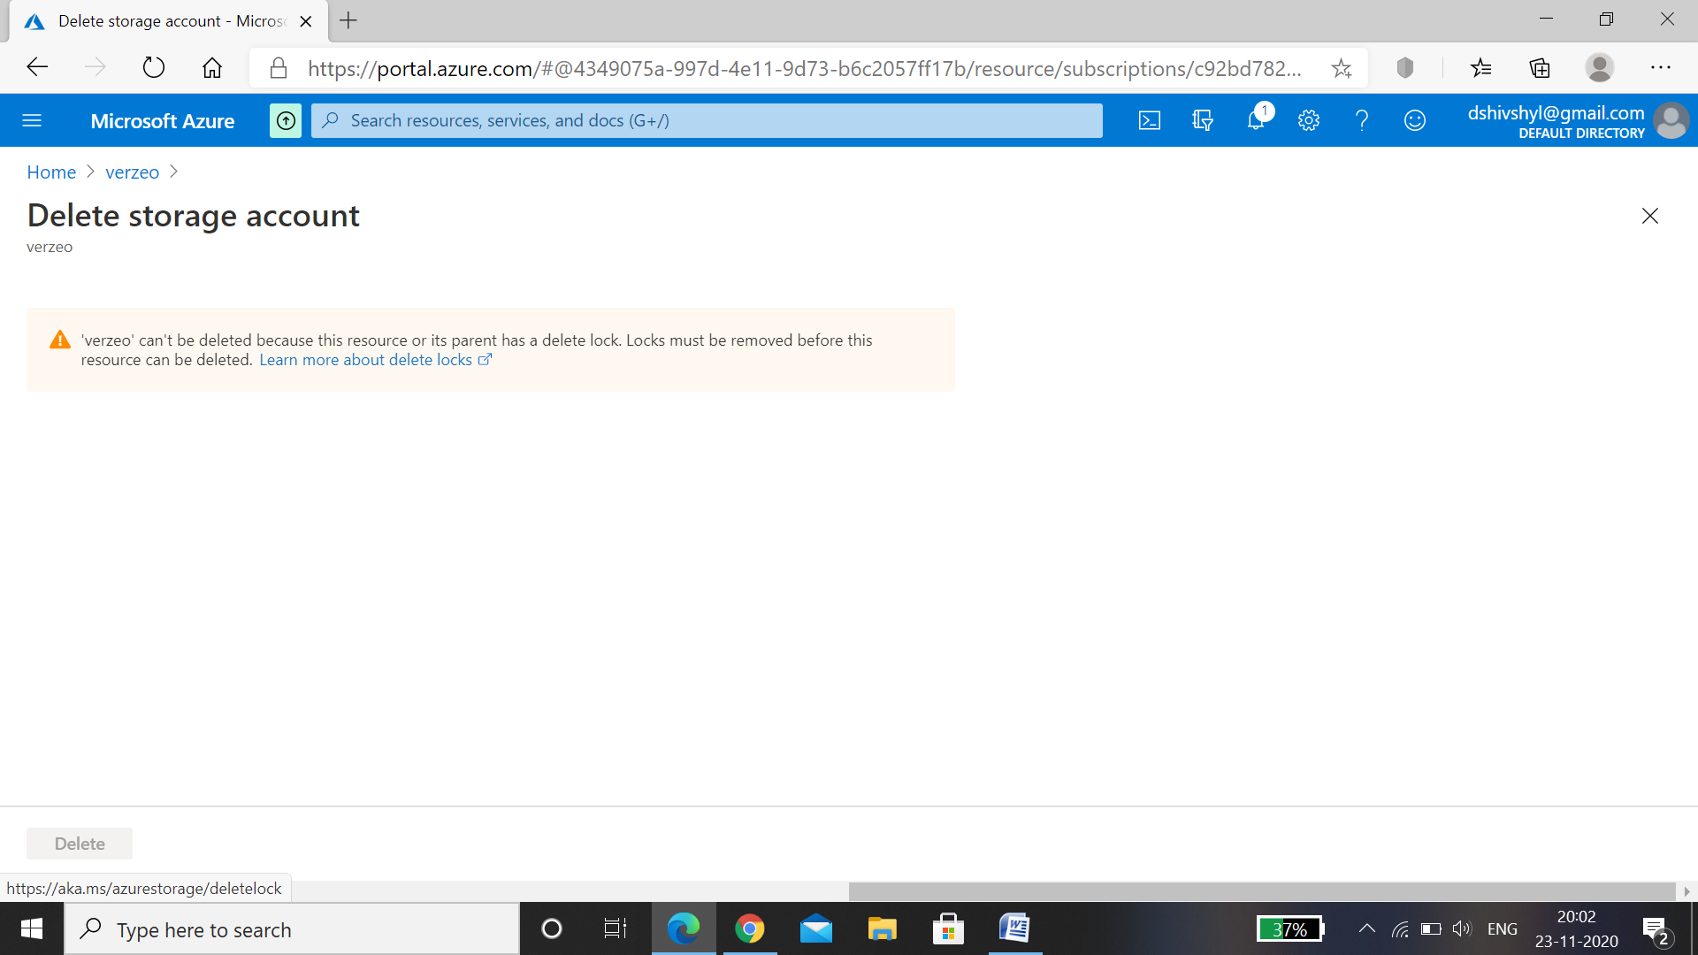

* CPU Threshold alert

The CPU Thresholding Notification feature notifies users when a predefined threshold of CPU usage is crossed by generating a Simple Network Management Protocol (SNMP) trap message for the top users of the CPU

* CPU Threshold alert for the VM (VerzVM01) is created.

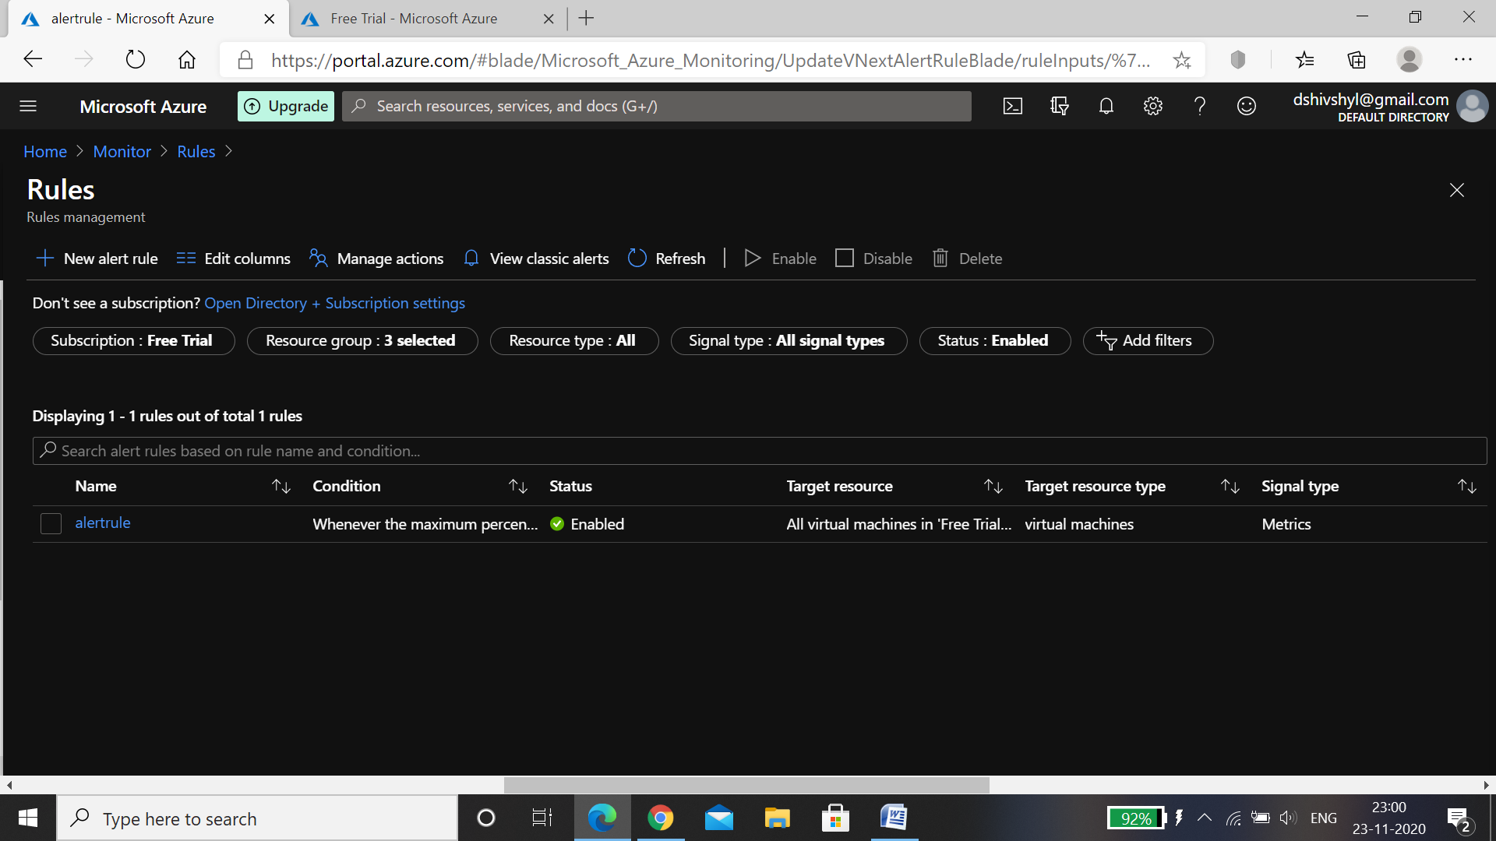

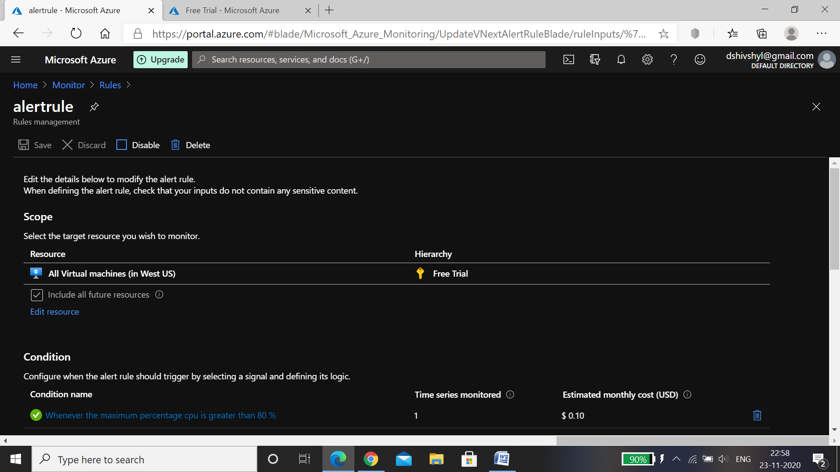

* Action group

Action Groups within Azure are a group of notification preferences and/or actions which are used by both Azure Monitor and service alerts.

* Action Group Verzactgrp is created and alert is sent to email id.

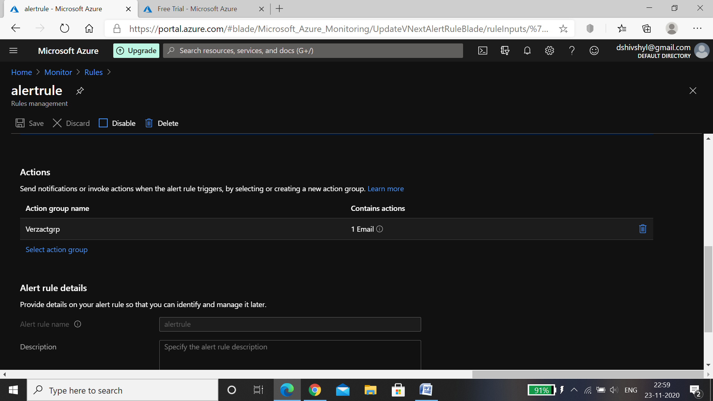

* Alert is received for the email id.

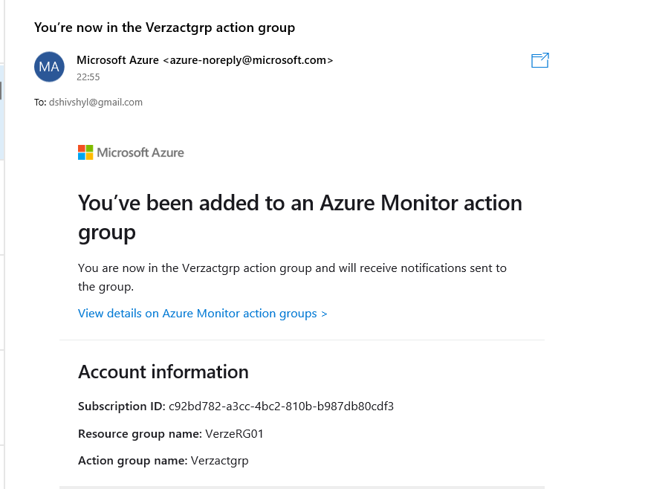

* Recovery Services vault :

A Recovery Services vault is a storage entity in Azure that houses data. The data is typically copies of data, or configuration information for virtual machines (VMs), workloads, servers, or workstations. ... Recovery Services vaults support System Center DPM, Windows Server, Azure Backup Server, and more.

* Recovery Services vault (Vezvault01) in the Resource Group (VerzeRG01)

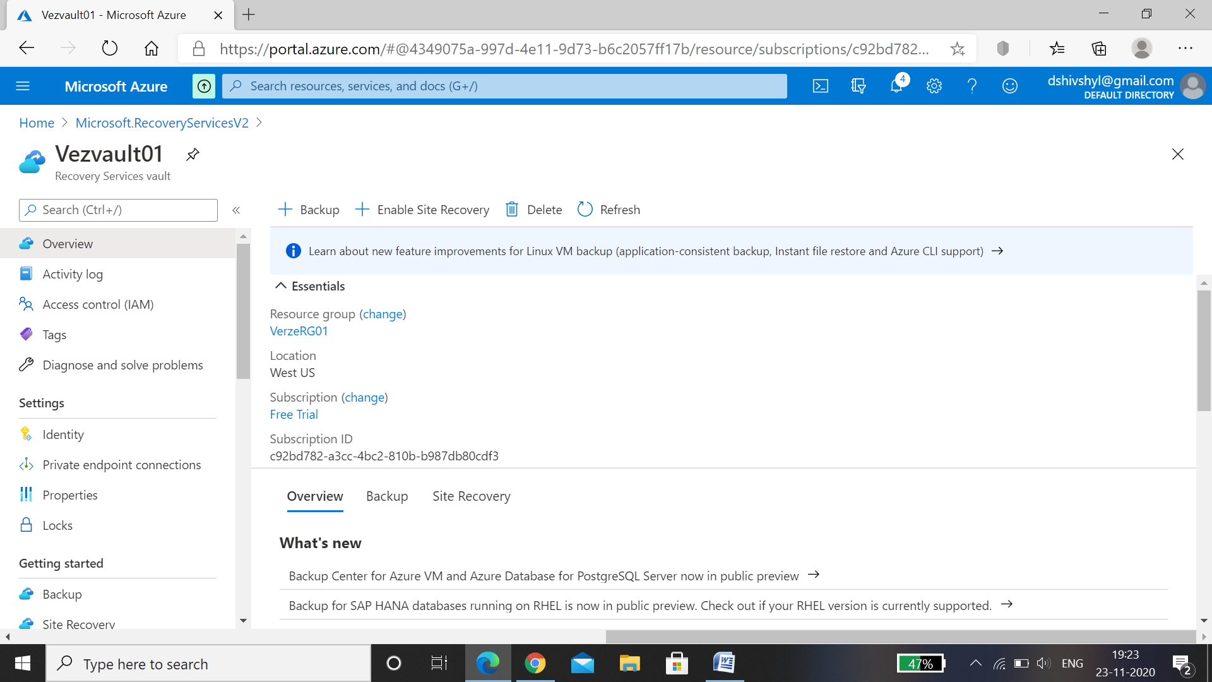

* BackUp:

VMware **backup** is the copying of data on a **virtual machine** (**VM**) in a VMware environment to prevent data loss. VMware **backup**, and **virtual** server **backup** in general, is a common challenge for storage and **backup** administrators. ... This allows for fast complete restoration of a **VM**.

* Backup for the Virtual Machine (VerzVM01) is setup.

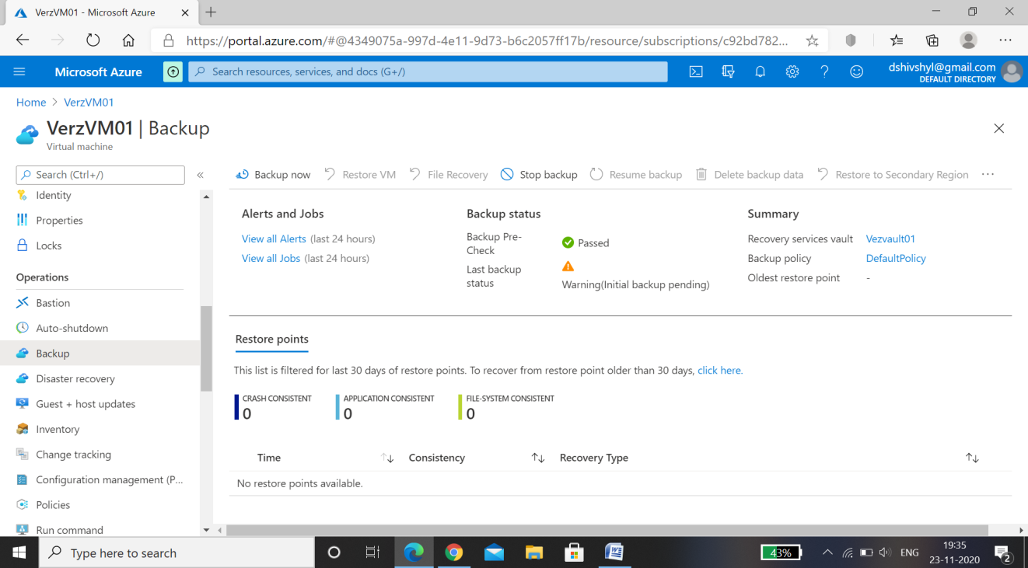

* Backup is completed successfully.

